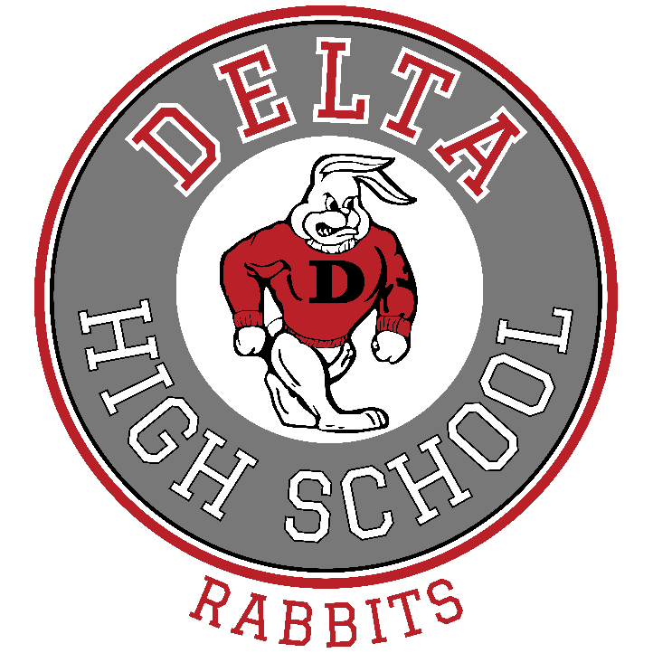

Delta High School
2022-23 Community Council

Jason Stefanoff (Chair/Parent) Jason.stefanoff0447@icloud.com 435-681-0447
Michael Lovell (Parent) mike.lovell@millardk12.org 435-253-0954
Cherish Works (Parent) Works_cherish@hotmail.com 435-979-0704
Kelli Anderson (Teacher) Kelli.Anderson@millardk12.org 619-251-7136
Sue Mork (Teacher) susan.mork@millardk12.org 435-406-4171
Michelene Anderson (Parent) michjex@yahoo.com 801-499-7601
Traci Keffer (Parent) mtkeffer@gmail.com 435-406-5646
Rob Fowles (Principal) rob.fowles@millardk12.org 435-864-5610

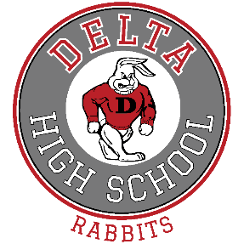
Delta High School 2021-22
Mission/Vision Statement

Delta High School students will learn and incorporate “RED” into their daily lives through:
R=Respect for themselves and others by feeling a deep admiration for someone or something.
E=Excellence in striving for personal best regardless of the circumstances.
D=Discipline in following the code of behavior in order to better oneself and the community.
Students can and will reach their potential and become productive members of an ever-changing society. DHS Faculty and Staff will promote positive learning and strive to help ALL students learn and reach their full potential through example and current teaching practices.

DHS Goals & Expectations 2022-2023

DHS Goals & Expectations 2022-23
School Improvement Plan

- Continue to review our data from Aspire and ACT information to improve all areas of testing.
  - All math, science and Language Arts at or above state average We have scheduled SEDC to come to our school and provide training for our teachers. SEDC offers a program called TECH Tuesday and on every Tuesday our teachers can receive training from technology professionals on different teaching and technology aides for our staff and teachers.
  - Incorporate a reading program and implement a regular day class for those students struggling in reading and focus on students who are testing low with their reading. ALL teachers will become teachers of reading. Teachers from different departments are working together to develop reading and writing improvement strategies for individual students. The Accelerated Reader program continues to be a focus in our school as we move forward.
  - Use data from the Aspire tests to help teachers target ways to improve to help those students be at or above the state averages. Teachers will give and access some Aspire pre-tests to see levels and how to improve based on their test scores and findings. Send Aspire results from the previous year to parents for them to review.
  - Use the PLC times to collaborate and find common methods that help those individual students become proficient or above proficiency. We encourage them to share their ideas and techniques with each other. We would like to portray the attributes of a Professional Learning Community in which all stakeholders play a part in the educational process. A Professional Learning Community is a condition of collaboration and teamwork in which ideas are developed and shared among all associated with the school. The parents, students, community, faculty and staff work together to create an environment of trust and collegial professionalism. We will work with our Community Council and send teachers to PLC trainings to help train and incorporate PLC’s in our school. Professional collaboration is very important if we are to get the best ideas and strategies from the people who know best. We must share successes and failures alike with each other so as to arrive at the best educational process for our students. We will set aside every Monday after school for our school wide PLC time as implemented by the district. We have increased the intensity and time donated to collaboration as we are now providing time for district wide collaboration. Departments from different schools are working on common assessments and curriculum mapping so we can provide consistent and better instruction for our students.

- Continue to prepare students for College and Career by incorporating the following:
  - All teachers will incorporate some kind of College and Career activity within the courses they teach. Teachers will be encouraged to make college visits and places of employment relating to the careers students are interested in.
  - Incorporate ACT test prep in ALL classes. Teachers will have in-service on testing prep programs MSD currently has.
  - Teachers will encourage deadlines, responsibility and accountability in everything we do.
  - Encourage all students to “Belong to Something” in an effort to teach life skills.
  - Bring in community “Career” employers to explain and give insight on what they do during our Friday Rabbit time. Have employers come to the Career Fair that we have scheduled through the counseling center.
  - We have hired a full-time employee to assist students with college applications, FAFSA, college visits and whatever we can do to get students involved in college or career opportunities.

- Put in place a new schedule (Rabbit time) with will be the last 15 minutes of each class on every Friday. This class is intended to give all students some additional time with their teacher to do things like: After the 2021-22 school year, refine and make a better resource for students to have more one on one time with their teachers or struggling areas of study.
  - Get caught up on missing assignments.
  - Understand class concepts that students are struggling with.
  - Get class time “one on one” help from the teacher.
  - Reward students for keeping caught up in class and understanding classroom concepts. (Positive Behavior Plan)
  - Use professional development money to send teachers to trainings to improve teaching strategies. Teachers are encouraged to attend conferences relating to their field of study. Also use funding to help teachers with advanced degrees.

- Increase the academic skills of our ESL students
Our ESL students are in need of extra help in most academic areas; especially when it comes to passing the mandatory standardized tests. We continue to update and purchase new computer software and other items to aid in the development of language skills. Our goal is to bridge the academic language barrier so students can more fully understand the concepts being taught. We will offer a class to help those students with a bi-lingual teacher in the classroom. They teach English skills as well as help the students with other curricular assignments they struggle with. We are meeting with the ESL students on a regular basis to help encourage them to be motivated to take advantage of the education offered them. They are encouraged to get involved with the extra-curricular programs offered at Delta High School which we feel will help them feel included and important. We continue to support the LIA (Latinos in Action) program here at DHS as this program affords many of our Latino students the opportunity to participate in a plethora of civic, school, and community activities. We feel that this program will boost self-esteem and encourage academic performance. This program has shown to have great benefit. We are trying to educate our ESL students to understand the resources available for them to progress toward citizenship, higher education, and employment. We have acquired information from other schools that seem to have a successful ESL program to help us in making decisions that will help our own students. It is deemed important that we work more closely with the ESL students at the middle school to help bridge that gap and promote earlier interventions. It is the goal of Delta High School that the number of ESL students passing end of level core tests increase.
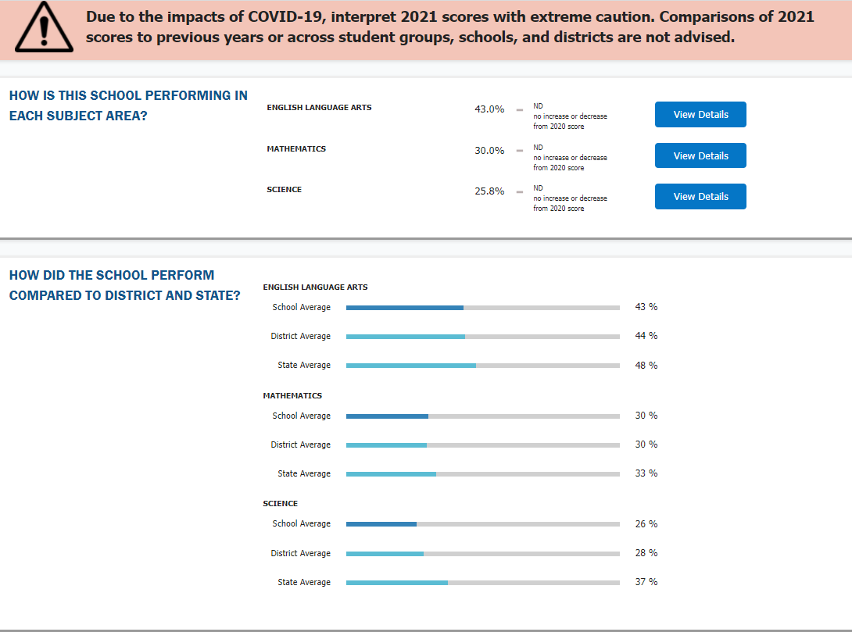

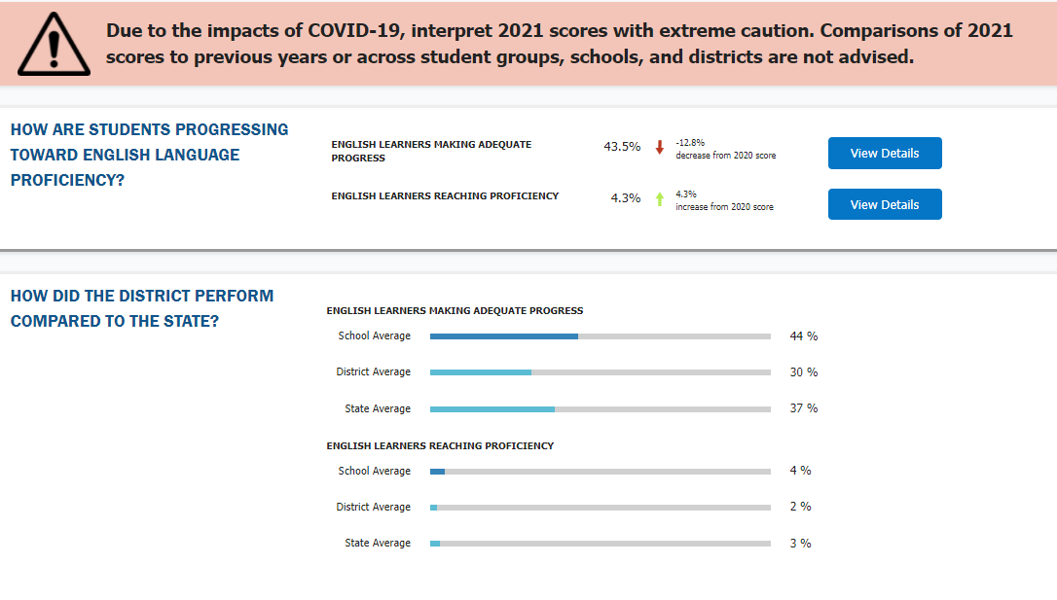

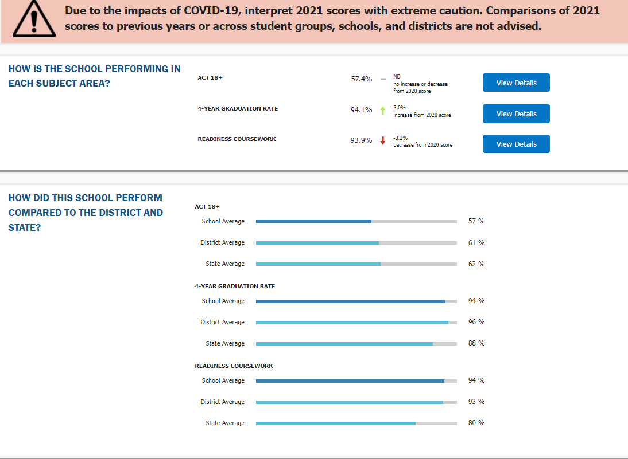

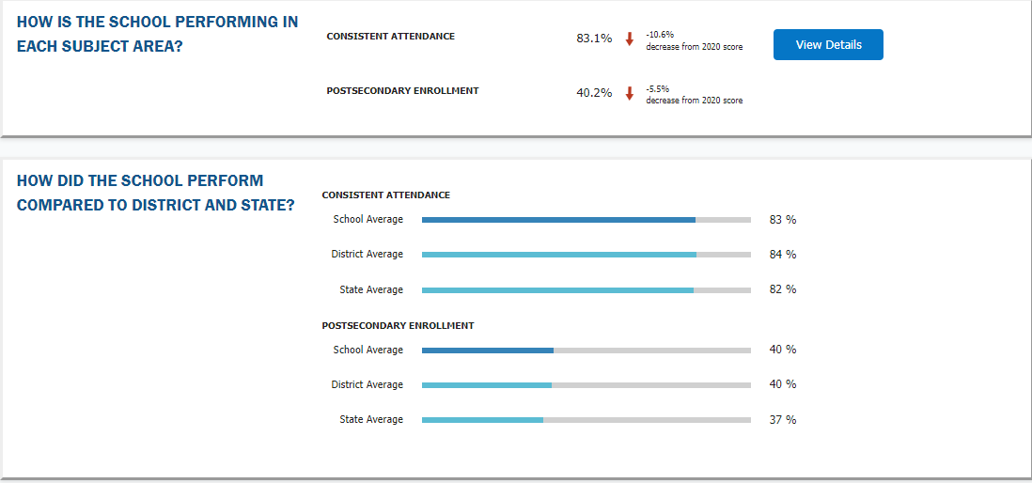

Delta High School Discipline Plan
Discipline Responsibilities:

Student’s Responsibilities: All students are expected to follow the rules and regulations of the Board of Education, the school administration, and the teacher. Students are required to be courteous, polite and contribute to our positive school climate.
Parent’s Responsibilities: Discipline is the primary obligation of the parents. It is the parents’ obligation, by teaching and example, to help their students develop appropriate behavior habits as well as proper attitudes toward the school. It is recommended that parents download the Powers School App and track their student’s grades and attendance.
School’s Responsibilities: It is the school’s responsibility to provide learning experiences free from distractions and misbehavior. Administrators, teachers and others connected with Delta High School shall provide positive models that serve as good examples for students to follow.

Student Conduct:
Students at Delta High School are expected to respect themselves and others. The following rules have been established by a committee comprised of students, parents, and school personnel. Students and parents should acquaint themselves with the guidelines established in order to help facilitate the smooth flow of the school.

D.H.S students will show respect and concern for self and others by:
- Using appropriate verbal or nonverbal language. No intimidating, abusive or obscene language, gestures, notes or inappropriate clothing will be tolerated at Delta High School.
- Speaking respectfully. Students should address all staff members by the proper names and titles.
- Being attentive in class, listening while others speak, staying in seat etc.
- Honoring appropriate requests from staff and other adults.
- Displaying non-disruptive behavior. Students will not be allowed to exhibit behavior that infringes on the rights of other students to learn.
- Refraining from any form of bullying (physical or emotional bullying, cyberbullying, hazing and retaliation)
- Allowing each person “personal space.” No fighting, intimidating or bullying of students will be allowed anywhere associated with the school.
- Refraining from the possession or use of tobacco, alcohol or drugs. In addition, lighters and matches are not permitted at school.
- Refraining from bringing any weapon from outside of school.
- Adhering to the guidelines of the Millard school District dress code policy.
- Treating school property with respect. We have a beautiful school and will not tolerate any vandalism to the school, the grounds, or the school property.

Consequences for breaking rules may include the following:
- Reprimand by the teacher
- Notification to parents/parent conferences
- Referral to counseling.
- Conference with principal or designee
- In-school or out-of-school suspension
- Expulsion from school
- Notification of police and removal from school

ALL insubordination will come directly to the office. Fighting and other activities that put others in danger will be dealt with according to the Safe Schools Policy.
Note: See Student Conduct Policy/Safe School Policy- Millard School District Handbook

Delta High School
SAFE TECHNOLOGY and DIGITAL CITIZENSHIP
HB 213, sponsored by Representative Stratton passed in the 2015 Legislative Session gave school community councils a new assignment to partner with school administration in creating a safe and constructive internet environment for students. As with other responsibilities of school community councils, it is intended that administrators, staff, and parents engage together to bring about the best possible result for students
At Delta High School the following safeguards are in place to provide a safe internet environment:
No Cell Phones during class – Delta High School is a “NO CELL PHONE IN CLASSROOMS SCHOOL” and students are expected to put their phones in a pocket as they enter the classroom. Teachers take roll with the cell phones to help students realize the importance of having cell phones put away during class time.
Internet Filters – All internet access is filtered through district network servers, which are in turn filtered through SEDC. The Southwest Educational Development Center filters provide a significant line of defense against access to inappropriate material.
Layered Network & Internet Access – Students, guests, staff and teachers, have layered access to online resources based upon a user profile setup at the district level. This profile significantly restricts unidentified guest and student access to online resources such as YouTube, Google, Images, etc.
Management Software – The school district uses management software to further control and supervise student online activities. Software such as MDM, Google Chrome Management, and LanSchool, allow teachers and district personnel to monitor and track student online activities in real time and historic time.
Acceptable Use Policy – The Millard School District requires every student and guardian to sign a copy of the Acceptable Use Policy every year. This policy outlines the terms and conditions of the privilege of using school network and internet connections. It also outlines expectations and consequences for violations of the policy.
NetSmartz Utah – The Attorney General’s Office provides schools with semi-annual training for students and staff in internet safety. Usually, students and staff will attend such training every other year in the form of assemblies.
Ongoing Threats – The ever-changing array of proxy sites that are designed to get around internet filters is a growing concern to schools; Smart phones with internet messaging apps are also a huge problem.

Delta High School
Professional Development and Instructional Practices

According to Accreditation surveys completed by faculty at Delta High, parents and students the area we need to improve is Standard 3 “The school’s curriculum, instructional design and assessment practices guide and ensure teacher effectiveness and student learning.” Therefore, we will be focusing our professional development on the following:

- Using data from student assessments and an examination of professional practice, school personnel monitor and adjust curriculum, instruction, and assessment to ensure vertical and horizontal alignment and alignment with the school's goals for achievement and instruction and statement of purpose.

- Teachers plan and use instructional strategies that require student collaboration, self-reflection, and development of critical thinking skills. Teachers personalize instructional strategies and interventions to address individual learning needs of students when necessary. Teachers use instructional strategies that require students to apply knowledge and skills, integrate content and skills with other disciplines, and use technologies as instructional resources and learning tools.

- All members of the school staff participate in collaborative learning communities that meet both informally and formally on a weekly basis during our “Late Start Wednesday” time allotment. Frequent collaboration occurs across grade levels and content areas. Staff members implement a formal process that promotes productive discussion about student learning. Learning from, using, and discussing the results of inquiry practices such as action research, the examination of student work, reflection, study teams, and peer coaching are a part of the daily routine of school staff members. School personnel can clearly link collaboration to improvement results in instructional practice and student performance.

- All staff members participate in a continuous program of professional learning that is aligned with the school's purpose and direction. Professional development is based on an assessment of needs of the school. The program builds capacity among all professional and support staff. The program is systematically evaluated for effectiveness in improving instruction, student learning, and the conditions that support learning.

- School personnel use data to identify unique learning needs of all students at all levels of proficiency as well as other learning needs (such as second languages). School personnel stay current on research related to unique characteristics of learning (such as learning styles, multiple intelligences, personality type indicators) and provide or coordinate related learning support services to all students.

Delta High School recognizes the existence of the possibility of a hostile attack, sabotage, or other violent action, as well as disaster/crisis resulting from fire, natural causes, or acts of school violence. Because of the reality of such an event and the state of the world today, Delta High School Faculty, Staff, Students, Parents, and community leaders are committed to providing the safest environment possible. We have prepared the Plan & Procedure for Crisis Management/Prevention to provide a framework in which the school can plan for and perform its respective emergency functions during school crisis situations. It is further designed to assist the staff in following the procedure with the greatest possible speed and safety. Regardless of the prescribed procedures, training, and instruction, we acknowledge that the sound judgment of the administration and staff is an integral part of safety management.

Standard Operating Guidelines | Standard Operating Guidelines
Teacher | Teacher
Fire | "Shelter in Place"- Hazardous Waste
1. Gather your class roster and accountability | 1. Upon hearing the activation of a shelter
card packet. | in place event, the staff will immediately close
2. Exit the building according to the fire escape route | all doors and windows leading to the outside
plan. Teacher is LAST! | environment.
3. Upon reaching pre-determined "outside"
class location, verify student accountability. | 2. Close doors leading to a hallway or
4. If all students are present, hold up your green | commons area.
card high above head until notified.
5. If all students are not present or you have extra | 3. Cover all openings with tape, paper, or
students; hold up the red card and write names on | other materials to prevent outside air from
post-it notes. | entering your room.
6. Send a designated runner with post-its to the
Group Leader. The Group Leader will contact you to | 4. Verify Student accountability.
determine possible locations of missing students.
 | 5. Wait for contact from group leader
 | via the intercom system.
Standard Operating Guidelines | Standard Operating Guidelines
Teacher | Teacher
Earthquake | "Lock Down" - (Violence or Intruder)
1. At the first sign of an earthquake, have all room | 1. Upon hearing the activation of a "lock
occupants "drop, cover and hold" remaining in the | down" event, the staff will immediately close
sheltered position for 60 seconds. Do NOT | all doors and windows leading to the outside
automatically rush your class into the corridor or | environment.
outside the building.
2. Account for all students.
3. Gather your roster and accountability card packet. | 2. Close doors leading to a hallway or commons
4. Exit the building when it is safe to do so. The | area and lock if possible
teacher LEADS the way out.
5. When leaving the area, take injured students only | 3. Move students to a safe place in the room
if moving them will not cause further injury. | where they will not be targets for people
6. Assemble in the pre-designated location. | outside the classroom.
7. If all students are present, hold up your green
card high above head until notified. | 4. Verify student accountability.
8. If all students are not present or you have extra
students; hold up the red card and write names on
post-it notes. | 5. Wait for contact from group leader via
9. Send a designated runner with post-its to the | the intercom system.
Group Leader. The Group Leader will contact you to
determine possible locations of missing students.

Millard School District Emergency Action Plan
Fire Earthquake Shelter in Place Violence
The Millard School District has a safe school policy which is intended to provide each student the opportunity to learn in an environment which is safe, conducive to the learning process, and free from unnecessary distraction. (Please see MSD policy 6090) In conjunction with the policy, Millard School District has implemented standard operating guidelines for emergency situations for schools within the district. Every school has been given guidelines and a list of procedures to help standardize emergency drills. Drills are practiced throughout the year for incidents concerning Fire, Earthquake, Shelter in Place (hazardous materials, or violence). Every effort is made to follow these standardized guidelines. Implementation may be slightly different due to school size, location, age of students, etc. The Millard School District continues to update and review its emergency procedures, policies, and materials. Copies of plans are available at each school and at the district office. Millard School District is working with other agencies to provide each school with the materials and supplies that are needed to successfully manage an incident. Together we are working at coordinating our efforts so that roles and responsibilities, communications, and responses to situations are clearly defined for each agency that may respond to an emergency. Please contact your local school if you have questions about emergency action plans or to volunteer your services.
Fire 1. Gather class roster and accountability card packet. 2. Exit the building according to the established fire escape route. Teacher is LAST. 3. Upon reaching pre-determined “outside” class location, verify student accountability. 4. If all students are present, hold up green card. 5. If all students are not present or you have extra students, hold up red card and write names on post-it notes. 6. Send a designated runner with post-its to the Group Leader. The Group Leader will contact the teacher to determine possible locations of missing students.
Earthquake 1. At the first sign of an earthquake, all room occupants “drop, cover and hold” remaining in a sheltered position for at least 60 seconds. Do NOT automatically rush class into the corridor or outside the building. 2. Account for all students. 3. Gather the roster and accountability card packet for reporting to the Group Leader. 4. Exit the building when it is safe to do so. The teacher LEADS the way out. 5. When leaving the area, take injured students only if moving them will not cause further injury. 6. Assemble in a pre-designated location. 7. If all students are present, hold up green card. 8. If all students are not present or you have extra students, hold up the red card and write names on post-it notes. 9. Send a designated runner with post-its to the Group Leader. The group Leader will contact the teacher to determine possible locations of missing students.
Shelter in Place 1. Upon hearing the activation of a shelter in place event, staff will immediately close all doors and windows leading to the outside environment. 2. Close all doors leading to a hallway or common area. 3. Cover all openings with tape, paper, or other materials to prevent outside air from entering the room. 4. Verify student accountability. 5. Wait for contact from Group Leader via the intercom or other means. Violence or Intruder 1. Upon hearing the activation of a “lock down”, staff will immediately close all doors and windows leading to the outside environment. 2. Close all doors leading to a hallway or common area and lock if possible. 3. Move students to a safe place in the room where they will not be targets for people outside of the classroom. 4. Verify student accountability. 5. Wait for contact from Group Leader via the intercom system or other means. 6. Doors are to remain locked until the “all clear” sign is given.
What are the Standard Operating Guidelines?
Standard Operating Guidelines pg. 2
Emergency Closure of School In the event that schools should be closed, or schedules changed for emergency reasons, such as storms, road conditions, unexpected hazards or health precautions, such information will be broadcast over radio stations FM 95.7, 93.7, 97.5 and AM 540, or via Power Announcement which will contact patrons by phone, text, or email. It is important for parents to keep such information current at their local school. Should school be dismissed early OR have a late start (2 hr. delay) due to inclement weather, all parents will be notified. Bus students will be bussed. Nonbus students need to be picked up/dropped off by parent or designated adult.
Answers to Parent Questions
1. What is my responsibility as a Parent/ Guardian during an emergency situation? In the event of a serious school or community incident, the school assumes responsibility for your children. You will be kept informed about what is happening and given instruction regarding your children through a local radio station and/or Power Announcement which contacts patrons through email, phone or text. Rushing to the school in your car or calling the school will only impede the school’s ability to protect your children and will hinder the communication process with other agencies involved. Children will NOT be sent home until parents/ guardians have been notified.
2. What do I do after I have been notified that I can pick up my child? Depending on the conditions and emergency, parents should park in the designated areas defined by each school in the child access routing plan. If indoors, parents should enter the school through the front doors and then proceed to their child’s classroom after signing in at the office. Parents will be required to sign that they are taking custody of their student for security reasons. If outdoors, parents should park in designated spots, find their child’s teacher and sign them out. Please do not encourage children to run to you or expect that they will come to your vehicle. To keep track of all students, parents MUST sign they have taken custody. If schools are in a lock down situation (violence or shelter in place) all doors to the school will be locked. Parents will put themselves and others in jeopardy if they try to enter the school. See #1 to see when it would be safe to pick up your child.
3. What will happen if I am not home or I cannot be reached? If parents are not at home or cannot be contacted during an emergency incident, the school will continue to assume responsibility of that student until the emergency contact person listed on the registration form has been contacted. It is very important that EVERY parent has an emergency contact person listed with the school who will take responsibility for that child until the parent/guardian is available.
4. If the school is unsafe, where will my child be? Each school will have an alternative site if it is necessary to move from the building. As each emergency is different, you will find out if your student has been moved by listening to the radio or you will be contacted via Power Announcement which uses email, text, and phone.
5. Is the school prepared with emergency supplies? Each school has some preparedness materials that they have gathered. In the case of an emergency, most classrooms have minimal supplies in a bucket that will help provide students with food, water, blankets, vital information about students, games and activities to keep them calm, and materials to help during shelter in place situations.
6. Is the staff qualified to help during an emergency? Staff members are given basic in-service training in first aid and CPR. Some staff member are trained members of CERT (Community Emergency Response Team) and have additional skills. Working in partnership with community agencies, additional training sessions are available throughout the county.
MSD Preparedness Activities Millard School District continues to work on emergency preparedness by being involved in the following activities: • Town/City CERT training program • MSD is part of the Local Emergency Preparedness Committee (LEPC). This committee helps coordinate activities among local, state and federal agencies and updates emergency procedures/policies • Continue training in first aid and CPR and annual practice drills of all types • PTA, PTO parental involvement • Annual updating of the MSD emergency preparedness handbook Things you can do to help 1. Be involved with the parent organization — volunteer to be on the safety committee 2. Volunteer to coordinate emergency supplies in your local school 3. Donate items needed to your neighborhood school. Following are some suggestions: Emergency blankets, ponchos, hand warmers, hand sanitizer, energy bars, trail mix, granola bars, jolly ranchers or other hard candy, wool blankets, water, duct tape, plastic, buckets, etc. Contact the school to see what is needed most. 4. Donate money to the MSD foundation or PTA for purchase of supplies Excerpt Millard County Sheriff’s Department Website “Sheriff Dekker urges all individuals and businesses to log onto the Sheriff’s Office website, www.millardsheriff.org, and follow the link to the "CodeRED Residential and Business Data Collection" page. Those without Internet access may call the Sheriff’s Office 435-743-5302 or 435-864-2755, Monday through Friday (8AM-5PM), to give their information over the phone. Required information includes first and last name, street address (physical address, no P.O. boxes), city, state, zip code, and primary phone number, additional phone numbers (optional)….The information will only be used for emergency notification purposes."

Trust Lands Proposal 2022-23
Delta High School
1. Printed Newspaper
Rationale: Having students be better writers is an ongoing goal in our language department. Our Journalism class has recently started our “Rowdy News” paper and using the funds to buy printed newspaper for their weekly, school newspaper articles.
Goals 1 and 2 – Language Arts at or above state average and College and Career Rediness.
Total: $2,500.00 (printed newspaper)
2. Professional Development
Professional Development money from the district is no longer available. This money will also be used to send teachers to conferences, training and other opportunities to improve teaching in the classroom.
Goals 1 and 3 – Math, science, and language arts at or above state average by investing in teacher professional development.
Total: $16,127.00 PLC Conference—7 teachers)
3. Advanced Degrees for teachers/Professional Development
Rationale: Our goal is to increase teacher knowledge, skills, and expertise within a variety of
teaching areas. We also hope secondary teachers will become eligible to teach college concurrent enrollment courses which will benefit our students. The maximum funded amount eligible to be claimed is $15,000 over a 3-year period, with ½ coming from the district and ½ coming from DHS LAND trust fund. If no teachers apply, the money will be used to send teachers to workshops and conferences to help them increase their knowledge in their specific subject area.
Goals 1 and 3 – Math, science, and language arts at or above state average by investing in teacher professional development.
Total: $ 2,500.00

4. Organizational planners
Rationale: Rabbit Academy is for incoming freshmen to help them have a better transition from middle school to high school. Helping them be more organized as they begin their school year will help them be better students.
Goal 2 and 3 – College and Career preparation and helping students to in keeping caught up in classes.
Total: $560.00
5. Science Department
Rational: Provide students with hands-on activities thru labs. This proposal is designed to enrich existing programs, with an emphasis on science learning through hand-on lab exercises. Students are in need of inquiry-based labs and career related science skills to reinforce the principles taught in the sciences.
Goal 1 – Science at or above state average.
Total: $20,750.00
6. IXL Math and ELA program
Rationale: IXL is a comprehensive on-line practice site for both math and English. IXL is used as a supplemental tool to help reteach concepts and provide extra practice to strengthen and improve student’s math and English skills.
Goal 1 – Math and language arts at or above state average.
Total: $5,990.00
7. Accelerated Reading Program
Rationale: The AR program is a supplemental tool used by Language Arts/Reading teachers to assess SSI (Sustained Silent Reading).
Goal 1 – Language arts at or above state average.
Total: $3,725.66
8. Calculators
Rational: Math Teachers have a need for some Texas Instrument TI-84 Plus CE calculators to
assist them in teaching math concepts.
Goal 1 – Math at or above state average.
Total: $8,760.00
9. Instructional Assistant
Rational: Hiring an instructional assistant to help manage a “Rabbit Academy” class that focuses on helping students transition to high school and a method of helping students learn in a study hall atmosphere.
Goal 1, 2 and 3 – Math, science, and language arts at or above state average and College and Career preparation and helping students to in keeping caught up in classes
Total: $28,628.31

10. ACT Prep Classes (Math, Science, English Teachers)
Rational: Teachers will teach ACT Prep classes before or after school prior to the ACT test in October, December, and March. This will be beneficial to helping students increase their ACT scores at DHS.
Goal 1 – Math, science, and language arts at or above state average.
Total: $3,150.00
11. Printers/Software
Rational: With the 3-D printers, students are taking their modeling projects a step further and printing them on a 3-D printer. New game software will assist students in learning more game engine programs to enhance their programming skills. These activities support science, technology, engineering, and mathematics (STEM).
Total: $3,749.00
12. Art Department
Rational: Our art classes are some of the most popular and well attended. The cost of the art supplies exceeds the money from the district allotted fees. Having our art students do pre- and post-tests, introductions to new art concepts and introducing a visual journal will help build the art knowledge in meaningful ways. The purchase of mallet instruments is needed to allow all students to be fully involved in our music program at DHS. These instruments could be used for our band and orchestra classes. There is sound educational research that supports studying the arts contributes to academic achievement and student success.
Goals 1 and 2 – Math, science and language arts at or above state average and College and Career Rediness.
Total: $17,531.52

Total estimated expenditures =$103,844.49

