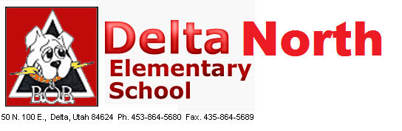
A Title 1 School
School Community Council Agenda
March 5, 2019

Conducting: Delna Bliss

- School Board Meeting

- PLC Training

- School Safety

- Other

