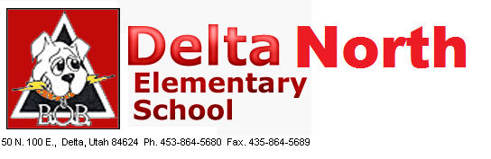
Delta North Elementary School
A Title 1 School
School Community Council

Conducting: Kelsey Gardner

- SB215: Teacher pay increase and vouchers

- School Land Trust – Budget

- DIBLES Results

- 95% Phonics

- Other:

