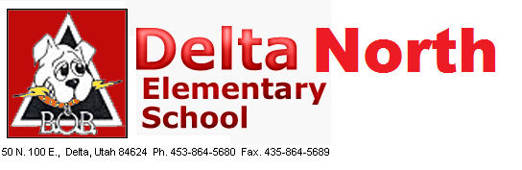
Delta North Elementary School
A Title 1 School
School Community Council
November 3, 2022

Conducting: Kelsey Gardner

- Governor Cox session – Kelsey

- School Land Trust – Possibly pay substitute stipend and increase to $50 per five substitutions?

- Delta North is a ‘B’ school!

- DIBLES results

- 95% Phonics

- DNES Expectations

- Safety – Drill Friday (Run, Hide, and Protect); Everyone Has Someone

- Other

