2020-2021 Parent Information Guide
Millard School District, 285 East 450 North, Delta, Utah 84624 Telephone: (435) 864-1000
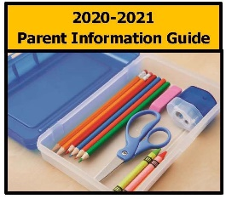
The 2020-2021 school year is now upon us and we are excited and prepared to begin another great year. All patron information is provided electronically. You can access this information on the Millard School District web page, which is located at www.millardk12.org, by clicking on the “2020-2021 Back-to-School Guide” link (as shown left). In this link you will find the school calendar, registration dates, immunization requirements, student policies, school lunch guidelines, free or reduced lunch application, school fees and fee waivers, and public information.
School Starts – Wednesday, August 19, 2020

If you need assistance with any of these items or need a printed copy, please feel free to contact us at the Millard School District Office at (435) 864-1000. We’d be happy to assist you!

Registration: There is really no need for you to attend registration as you can complete the registration forms in your PowerSchool Parent Access Account, apply for free/reduced meals online, and pay your fees online by visiting our website. New students and those needing class changes that cannot be mitigated over the phone or by email, registration will be held at the individual schools on Wednesday, August 5, 2020 & Thursday, August 6, 2020 at the following times by last name for social distancing regulations due to COVID-19.

9:00-10:30 (A-C) 10:30-12:00 (D-K) 12:00-1:30 (L-R) 1:30-3:00 (S-Z)

EskDale High School – Wednesday, August 12, 2020 – 2 p.m-7 p.m. (Utah time)
Garrison Elementary School – Monday & Tuesday, August 17 & 18, 2020 – 9 a.m.-5 p.m. (Utah time)

Si usted necesita material en Español, por favor visitenos en nuestra página de internet haciendo click en el link de Español. Si usted aún necesita foto-copias de este material en Español, por favor llame por teléfono.

ECRWSS
U.S. POSTAGE
PAID
EDDM RETAIL

Local
Postal Customer
Millard School District
285 East 450 North
Delta, UT 84624
(435) 864-1000

