Fillmore Middle 2021 – 2022
Teacher and Student Success Plan

Prepared by:
FMS Community Council

Ian Adams | Chair
CJ Alldredge | Vice Chair
Matt Bassett | Principal
Vickie Larsen | Teacher
Lola Murdock | Teacher
Lorna Adams | Parent
Amy Despain | Parent
Natalie Ralphs | Parent
Maria Ruvalcaba | Parent

School Grade
2014 B
2015 B
2016 A
2017 B
2018 B
2019 B
2020 COVID Hijacked Us

* School grading changed significantly during 2018. There are now three components to the school grade; achievement, growth, and English learner progress.

Here are how the new indicator ratings correlate to the old letter grade:

Elementary and Middle Schools (150 possible points)
- A – Exemplary School; 63.25% of total points earned
- B – Commendable School; 55% of total points earned
- C – Typical School; 43.5% of total points earned
- D – Developing School; 35.5% of total points earned
- F – Critical Needs School; less than 35.5% of total points earned
Here is our 2019 data:

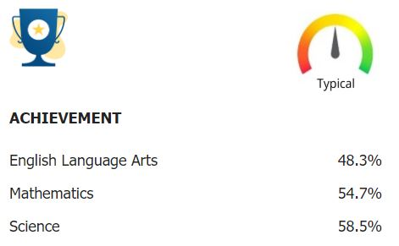

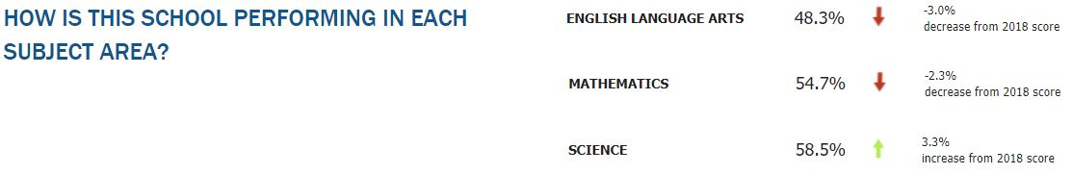

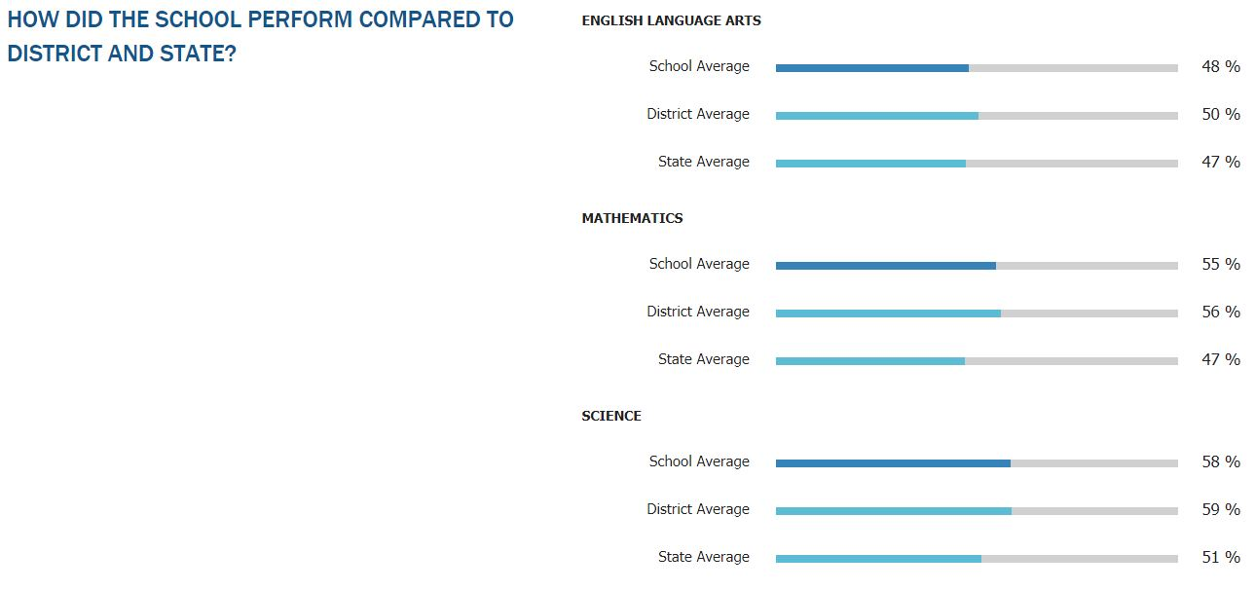

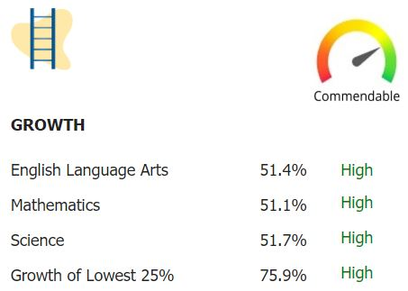

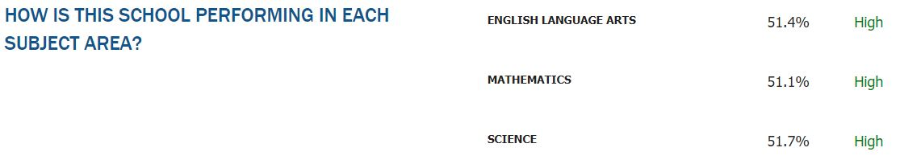

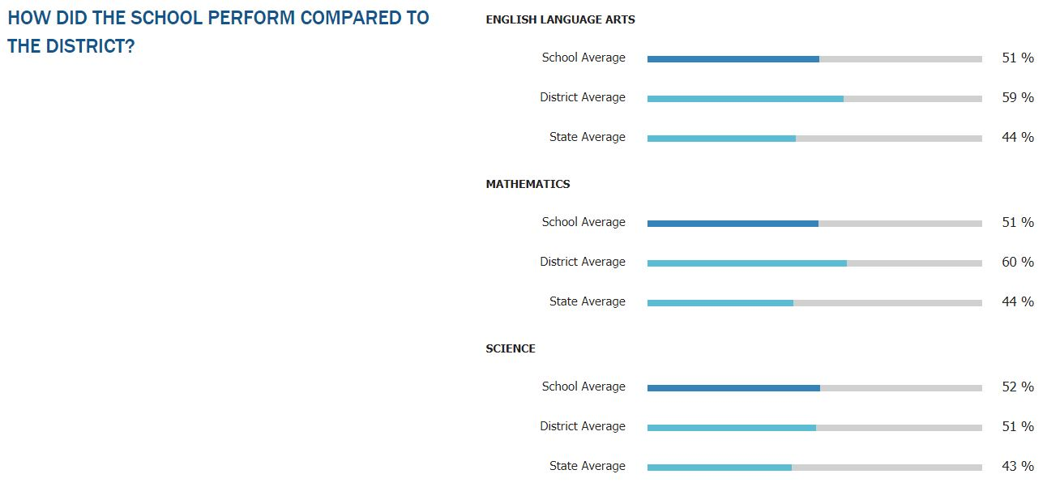

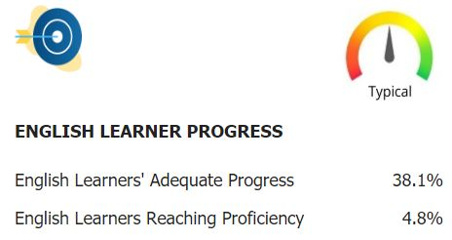

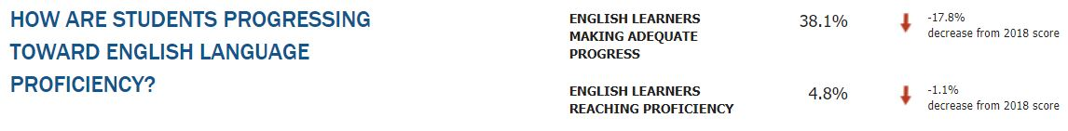

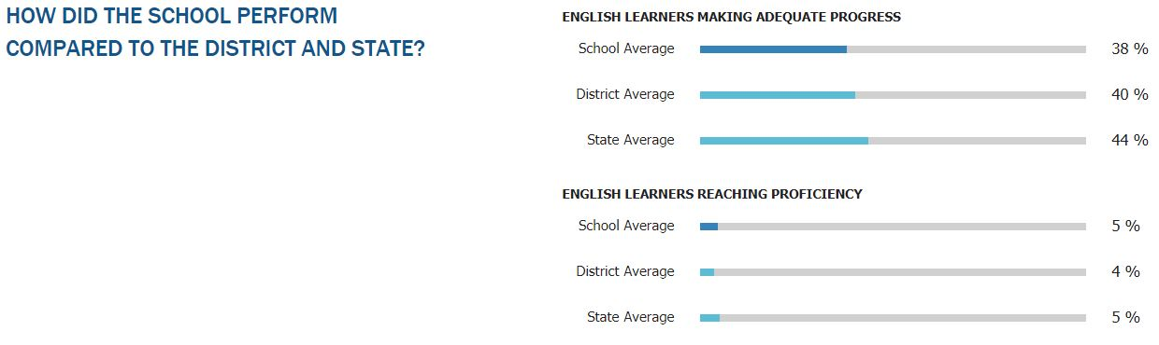

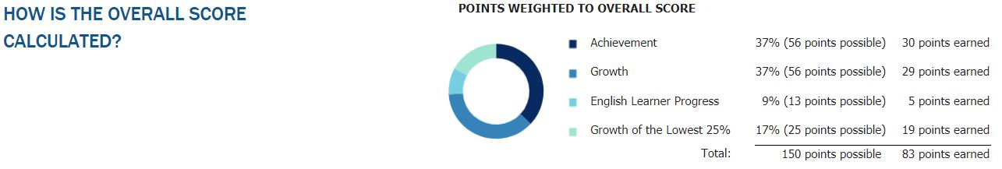
Follow Up from our 20-21 Land Trust Plan
Our 20-21 Land Trust Plan consists of four goals to increase student achievement.
- Provide Enrichment Opportunities
- Provide Intervention Opportunities
- Provide Professional Development for Teachers

Goal | Program | Projected Cost | Follow Up
1 | Art Specialist | 22960 | on track
1 | Beverly Taylor Specialist | 3302 | on track
1 | Maben's Prep | 10,708 | on track
2 | IXL | 4413 | 4413
2 | Lexia | 4000 | 4000
3 | Monthly PD | 10000 | on track
3 | Lola’s Masters | 1800 | 784
3 | Maben's Masters | 1800 | 670.5
3 | PLC Institute | 11000 | 0
 | TOTAL: | 69983

The plan is coming along well. We have been trying to get our teachers to the PLC Institute in Vegas. Those plans keep getting derailed by the pandemic. We are excited about an opportunity to live stream an event this August which will allow us to attend the conference virtually. It won’t be quite the same as attending one in-person, but it certainly is better than putting it off. We will continue to place a high priority on providing teachers the opportunity to attend an in-person conference.

School Land Trust Plan

Our Teacher and Student Success Plan consists of three goals. It is our belief that these goals will lead to an increase in student achievement. Our goals are:

- Enrichment – We believe that by providing programs that recognize and make provisions for the needs of gifted and talented learners, we will help them along their way in reaching their full potential, and improve upon their achievement. Our goal is to have students participate more in the arts.

This is how we plan on using Land Trust funds to help us reach our 1st goal.
- We would like to fund an art instructional specialist for 5.75 hours each day. This specialist will provide weekly instruction to all of our 5th and 6th graders, as well as 6 sections of art for our 7th and 8th graders.
- Clayton Barber teaches music weekly to our 5th and 6th graders, which is eligible for funding from the Beverley Taylor Sorensen teaching arts program. We’d like to utilize this grant to cover a portion of his salary.

- Intervention – We believe that by providing programs that recognize and make provisions for the needs of learners who are below the level of their age peers, we will help them along their way in reaching their full potential, and improve upon their achievement. Schoolwide, we would like to increase both our Math and ELA RISE proficiency scores by2%.

This is how we plan on using Land Trust funds to help us reach our 2nd goal.
- We would like to purchase Lexia licenses for our 6th graders. Lexia addresses the development of oral language, reading, spelling, and writing skills for students who are learning English.
- We would like to purchase ALEKS licenses for our 7th and 8th graders. ALEKS is a web-based artificially intelligent assessment and learning system for mathematics.

- Professional Development – We believe that teacher professional development has a direct influence on instruction and a positive correlation with student achievement. It is also our belief that every teacher should engage yearly in some type of professional development. Schoolwide, we would like to increase both our Math and ELA RISE growth scores by 2%

This is how we plan on using Land Trust funds to help us reach our 3rd goal.
- We would like to pay teachers 1 hour each month at their hourly rate. This time will fall outside of contract time and will be used for monthly professional development opportunities.
- We would like to send as many teachers as possible to the PLC institutes both this August and next June

We are projected to receive $68,485 in funding. Here is our cost breakdown.

Goal | Program | Projected Cost
1 | Art Specialist 5.75 hours | 22960
1 | BTS Specialist | 3800
2 | ALEKS | 1795
2 | Lexia | 5000
3 | Monthly PD | 9122
3 | PLC Institute | 25808
 | TOTAL | 68,485

**Addendum: Carry over funds, and funds allocated but not used, will be put towards our professional development goal. There are often PD opportunities that fall on a Saturday. We would like to pay teachers at their daily rate when this were to happen. We are interested in seeking out gifted and talented PD opportunities.**

School Safety / Digital Citizenship Plan
We have decided to focus on Digital Citizenship as the topic of our school safety plan. To ensure that our students are adequately prepared to be a productive digital citizen, we will do the following:

- We will use commonsense.org for our Digital Citizenship platform. Lessons will be given each month at each grade level.
- Incorporate a Digital Respons-Ability assembly, provided by the Attorney General’s office, every other year to provide additional training.
- Incorporate an assembly offered by our SRO during the off years of the NetSmartz assembly to provide additional training.
- We are exploring introducing NOVA curriculum to be taught by our SRO. Topics include: Internet Safety, Social Media, Drugs, Self-Esteem, Bullying, Anger Management, Heroes and Role Models.
- Provide teachers annual training on NetRef.

Need a signature page

